FINAL SRS REPORT

Northside Cafe Online Management System



**SUBMITTED BY:** Submitted To:

Smriti Shrestha Nadia Faisal

Roshani KC

Camilla Jepsen

Diya Patel

Mijal Maharjan

Gozde Nur Yigit

# 

Table of Contents

Introduction 3

Project Description: 3

Project Scenario: 3

Project Objective: 4

Purpose: 4

Project Scope 4

Key Deliverables: 4

Stakeholder Management Strategy 6

7

Flowchart of Northside Cafè: 7

WBS STRUCTURE 8

Budget Breakdown 9

Functional Requirements: 10

Non -Functional Requirements: 11

System Requirement: 12

Business requirement: 12

System Design Specification: 14

System Components 14

Methodology: Agile Methodology for Development 15

System Configuration: 16

Hardware Configuration 16

Software Configuration 18

Use case Diagram: 19

Data Flow Diagram 20

Context Diagram 20

Level 1 Data Flow Diagram 21

Level 2 DFD Diagram–Detailed 22

Class Diagram 23

UI Design & Story Boards 24

Database Requirements: 46

Database Table: 46

Entity Relationship Diagram: 49

Relationship Table 50

51

Test plan 51

System Implementation Plan 52

Data Protection Impact Assessment (DPIA): 53

Data Encryption and Anonymization: 53

Conclusion 54

Reference list 54



# Introduction

With a specialized focus on sustainability, customer experience and quality of service, Northside Cafe is planning to seek an enhancement to open its new branch and manage operational performance by implementing an automated point of sale (POS) system tailoring its specific needs. This project will focus on delivering an exceptional coffee and cafe experience as well as manage the daily sales transactions and operations of Northside Cafe in order to enhance operational efficiency and minimize the risk of manual errors.



# Project Description:

Northside café wants to expand the café in Melbourne CBD so the cafe wants its own POS system to manage the shop and change the manual process to digital. The project embraces developing an automated system that can handle and manage the café daily sales transactions more efficiently. The system has secure login features based on the levels and roles to access the POS system. The design system will be able to manage sale transactions, store data, detail sale monitoring and generate reports and receipts. The user will be able to manage and customize their coffee, account and make secure payment.



# Project Scenario:

The Northside Cafe is currently using a manual and dated system to run the café. The difficulties that may arise through the project development include inefficiencies, data retrieving, and the sale transaction process. Thus, the currently used manual system creates security threats as there is a weak restriction on the role-based access control and a high risk of human error, time-consuming and real-time tracking.

To solve this problem, the system should have updated technology having an automated system that can manage and handle the day-to-day sale transactions of the café, real-time tracking and reporting, inventory management, and access control.



# Project Objective:

The main objective of the Northside café is to create a POS system for the online management system of the café which enhances productivity and efficiency. The system aims to design an automated and streamlined for storing, and monitoring transactions to decrease the error and increase efficiency. The system serves as a bridge for managing sales transactions, staff management, customer information and various other aspects that contribute to the efficient optimization of its resources.



# Purpose:

The Purpose of the Northside café is to replace the outdated and manual version of the system with an integrated digital POS system which is an automated system. The goal is to develop a design that can handle every sale transaction that happens every single day and be able to generate a report based on the transaction and should be able to manage the inventory. Create a system that is scalable with the future growth and demand. Enhance security, error, level of privilege and user-friendly and comprehensive service.



# Project Scope

## Key Deliverables:

* Authentication Management:
* Secure login for user, which should have role-based access control.
* Also, policies for secured passwords and user activity tracking.
* Sales Management:
* Develop a system which can handle daily sales transactions.
* Secure Payment processing.
* By minimizing the error, we can improve the customer and user experience.
* Reporting:
* The system should be able to generate printable detailed sales and performance reports.
* Should be able to filter Daily sales report by date and user.
* User Interface Design:
* The interface of the system should be user-friendly and easy to navigate in order to improve user satisfaction.
* Also, should be compatible with another platform.
* Product Management:
* System should be able to add, list view, update and delete products.
* Should be able to provide accurate inventory update, we can try to minimize waste and can track the demands of the customer.
* Data protection:
* By conducting DPIA, we can make sure if our system is meeting with the data protection rules or not.



# Stakeholder Management Strategy

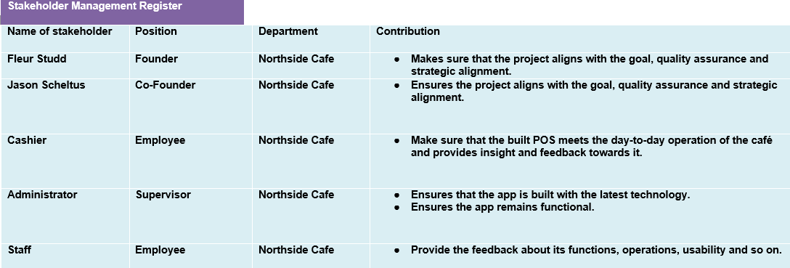

# 

# Flowchart of Northside Cafè:

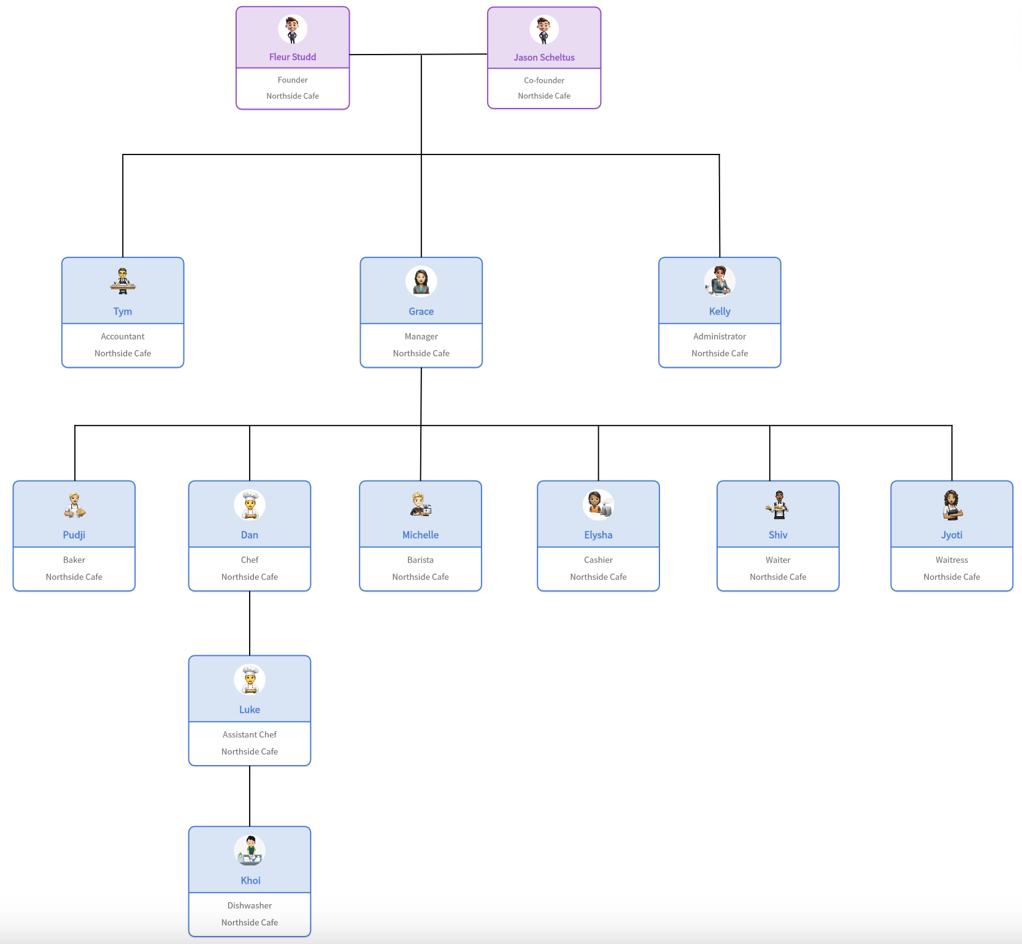



# WBS STRUCTURE

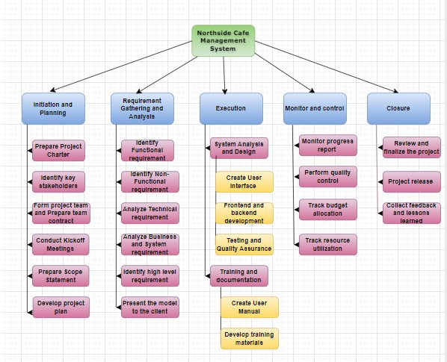



# Budget Breakdown

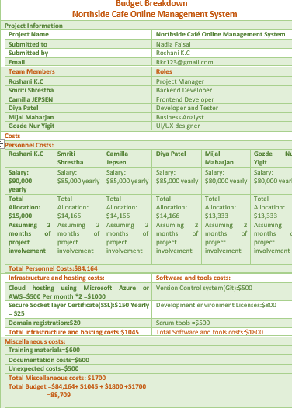

Fig: Budget Breakdown



# Functional Requirements:

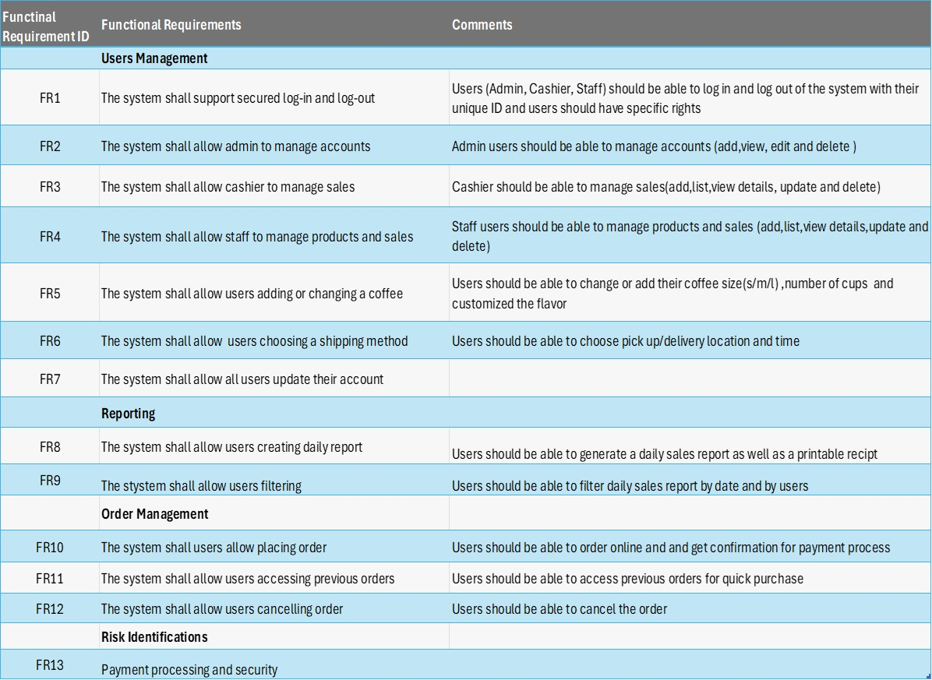

# Non -Functional Requirements:

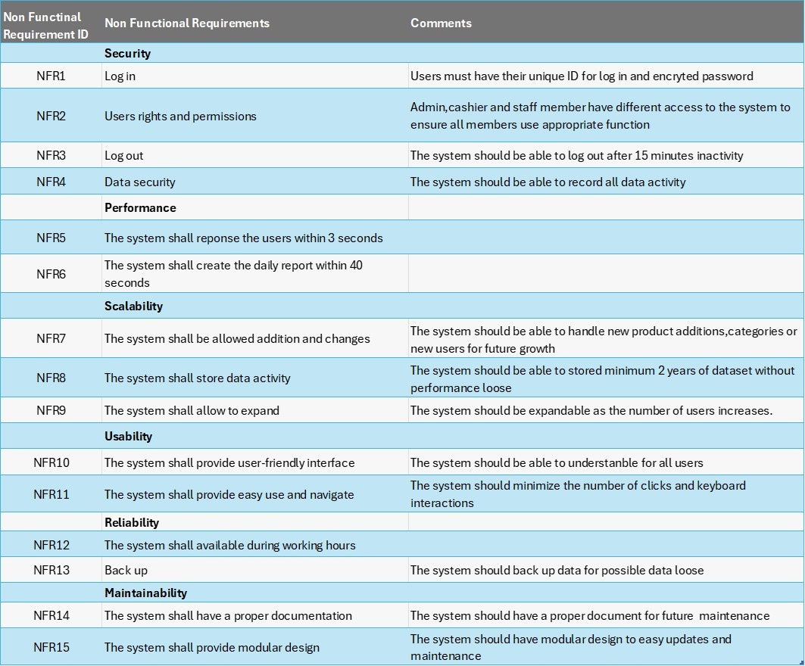

## System Requirement:

The hardware and software needed to run an application are referred to as system requirements.

* Hardware Requirements: (*6 Necessary Point of Sale Hardware Components* 2021)

A monitor, scanner, receipt printer and a customer facing display.

In order to tackle processing of data, server’s performance should be high.

Network should be stable and secure as well as the routers and firewalls.

* Software Requirements:

Operating system of the POS should support Windows and iOS.

Barcode scanner should be compatible.

A device with a CPU speed of 1 GHz or greater, 1 GB of RAM, and 3GB of hard drive space are required to operate a point-of-sale system (POS). *(6 Things You Need to Setup Your POS 2019)*

System should have antivirus and firewall software.

## Business requirement:

(Solutions 2023)

A successful point-of-sale system is built on a user-friendly interface. It should be simple to use and intuitive for your employees.

A good point-of-sale (POS) system should enable real-time inventory tracking, automatic reordering, supplier management, and item categorization for improved organization.

The point-of-sale system ought to offer comprehensive sales insights.

Customer satisfaction depends on efficient payment processing that complies with industry norms and laws.

A scalable solution should make it easy for you to grow your business and add more locations without encountering major technological challenges.

Software updates and data syncing are two benefits of cloud-based point-of-sale (POS) systems, which save maintenance requirements.



# System Design Specification:

## System Components

a. User Interface (UI) Design:

· A user-friendly interface that is intuitive for different roles (Admin, Staff, Cashier).

· Less clicks required and availability of direct navigation to make users more efficient.

· Completely responsive design compatible across various devices.

b. Backend Architecture:

· A powerful server-side application managing business logic, data management and user authentication.  
· Scalable database architecture for secure storage of sales data, inventory items as well as users’ information.  
· APIs to link the front end with the back-end database maintaining security and ensuring data integrity.  
c. Security Features:

· In order to restrict access based on a person’s role, Role-Based Access Control (RBAC) is used.  
· Data encryption at all levels- transmission or storage for sensitive information.  
· Regular security audits and updates addressing vulnerabilities.

d. Reporting and Analytics:

· Real-time reporting of sales reports, stock statements and also user activities occur within no time.  
· Reports generation customization depending on what users need or according to their roles.  
· An easy dashboard with quick access towards key performance indicators (KPIs).  
e. System Integration:

· Incorporation with the payment processing system that is already present.  
· On the same wavelength with different hardware devices or peripherals like; receipt printers, cash drawers, & barcode scanners.

## Methodology: Agile Methodology for Development

a. Requirements Gathering and Creating a Backlog:

· Involve the stakeholders (coffee owners, employees etc.) in order to gather requirements.  
· Set up a product backlog and prioritize features by ensuring that the most important items are listed first.  
  
b. Sprint Planning:

· Divide the project into manageable sprints which may last for about 2-4 weeks each.  
· Establish sprint goals and determine what can be delivered during each sprint.  
  
c. Prototyping & Design:

· UI/UX designs along with system architecture’s prototypes are designed initially.  
· Ensuring that designs meet user needs by obtaining input from stakeholders and making changes to them iteratively.  
  
d. Development:

· Developing features incrementally on various system functionalities throughout all the sprints (examples being sales management and authentication)  
· Continuous testing and integration in order to ensure that newly added codes do not interfere with existing functionalities of the system.  
  
e. Quality Assurance & Testing:

· Each sprint should include unit tests, integration tests and user acceptance testing (UAT).  
· If any bugs are discovered or issues arise during the test, they should be addressed before moving on to the next sprint.  
  
f. Deployment and Monitoring:

· Incrementally deploying the system even though with a pilot phase.  
· Monitoring the performance of the system continuously, collecting user feedback, & planning new sprints for future purposes to improve & to add new features.  
  
g. Maintenance:

· Bug-fixes must be cautiously carried out continuously for the security overhaul and addition of features meant to meet changing user needs according to shareholders’ feedback.  
· Using Agile iterations and making sure that it is aligned with cafe goals while fulfilling customer requirements, as well.



# System Configuration:

## Hardware Configuration

"In the POS system, the integration of advanced hardware is essential for performance (Maranatha Christian University, 2024)."

a. Point of Sale (POS) Terminals:

· Processor: Intel Core i5 or higher.  
· Memory: Minimum 8GB RAM of 3200 MHz to make sure everything runs smoothly during peak hours and to mitigate data inefficiency.  
· Storage: SSD with at least 512GB storage (e.g. Samsung 870 EVO) for faster data access and retrieval.  
· Display: Minimum 15-inch touch-screen display that makes interaction easier for staff.  
· Network Interface: Ethernet and Wi-Fi capability for flexible networking.

b. Server Hardware:

· Processor: Intel Xeon or equivalent, with multiple cores for super-fast processing of the information.  
· Memory: Minimum 16GB DDR4 RAM of 3200 MHz or higher, which has the capacity for scalable to 32GB for future.  
· Storage: RAID-configured SSD storage with at least 1TB capacity for optimal speed and data redundancy.  
· Network: Gigabit Ethernet for high-speed data transfer within the network of cafes.  
· Backup Power Supply: Uninterruptible Power Supply (UPS) to prevent data loss during uncertain power outages.

c. Networking Equipment:

· Router: Router which is high-performance which supports dual-band Wi-Fi for secure and fast connectivity.  
· Switches: Managed switches to control network traffic effectively.  
· Security Devices: VPNs and firewalls for secure remote access and protection against cybercrimes and theft of important data.

d. Peripheral Devices:

· Receipt Printers: High-speed printers.  
· Barcode Scanners: Mounted scanners for efficient product entry.  
· Payment Terminals: Compatibility with major payment options for credit/debit or mastercard transactions.  
· Mobile POS Devices: Tablets or smartphones with POS software installed for easy mobile transactions.

## Software Configuration

a. Operating System:

· POS Terminals: We decided to go with Windows 10 Pro or Linux-based OS for better security and user-friendly reasons.  
· Server: Windows Server 2019 or Linux-based server OS (e.g., Ubuntu Server) for reliability and security.  
b. Database Management System (DBMS):

· MySQL 8.0 or PostgreSQL for relational databases which are famous for robust and adaptable data management.  
· MongoDB for non-relational databases.  
c. POS Software:

· Purchased off-the-shelf or Toast POS-system which is customized to Northside Café's specific needs.  
· Inventory management, sales processing, reporting, customer management, and secure login.  
· Compatible with payment processing gateways, & accounting software.

d. Security Software:

· Antivirus/Anti-Malware: Antivirus software on all devices to protect against threats.  
· Encryption Software: Tools for encrypting sensitive data like AES Crypt stored on the server and transmitted over networks.  
· Firewall Configuration: FortiGate Next Generation Firewall (NGFW) Software and hardware firewalls are used in order to prevent unauthorized access. "The Point of Sale (POS) system of The Northside Café requires robust firewall protection to prevent unauthorized access and secure its operations (Tris, 2024)."  
  
e. Backup and Recovery Software:

· Backup Solution: Automated backup software like IDrive that supports full backups of the database and system configurations.  
  
· Recovery: Disaster recovery tools like GEA Aroma recovery system to restore system functionality in case of hardware failure or data corruption.



# Use case Diagram:

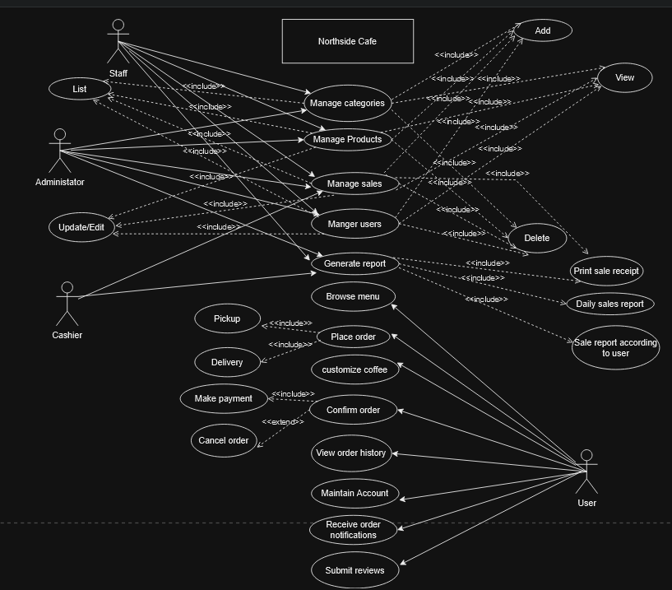

((Schader & Korthaus 2012)

Fig: Use case diagram of Northside café Management system



# Data Flow Diagram

## Context Diagram

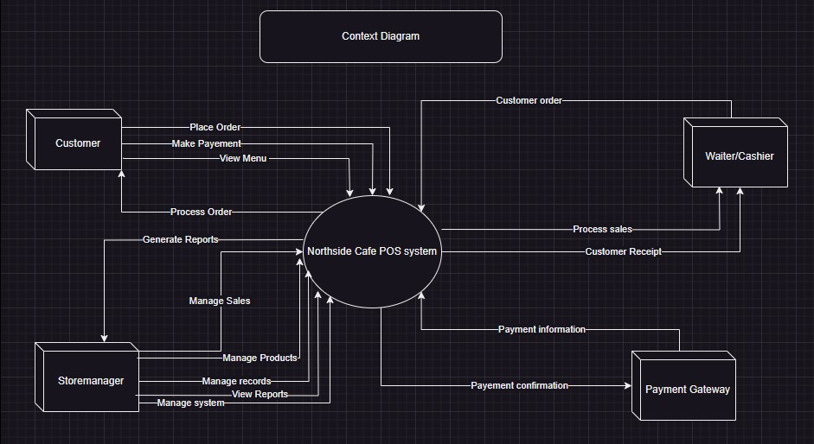

(Bograin, 2017)

Fig: Context Diagram of Northside Cafe Management System

## Level 1 Data Flow Diagram

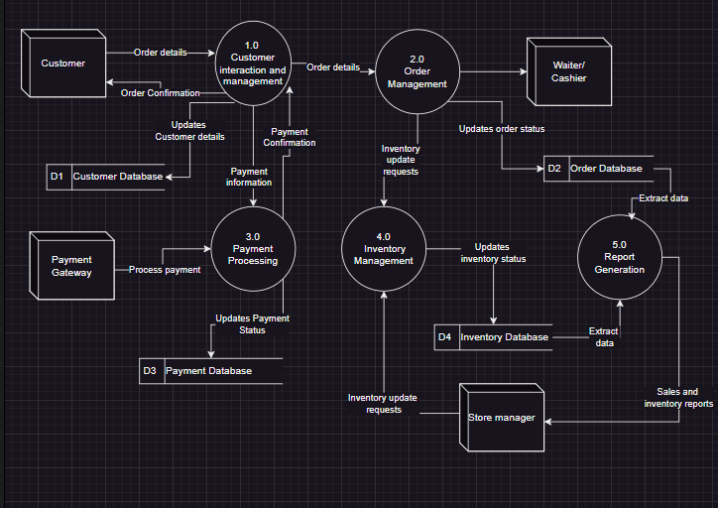

(Bograin, 2017)

Fig: Level 1 DFD Diagram of Northside Cafe Management System

## Level 2 DFD Diagram–Detailed

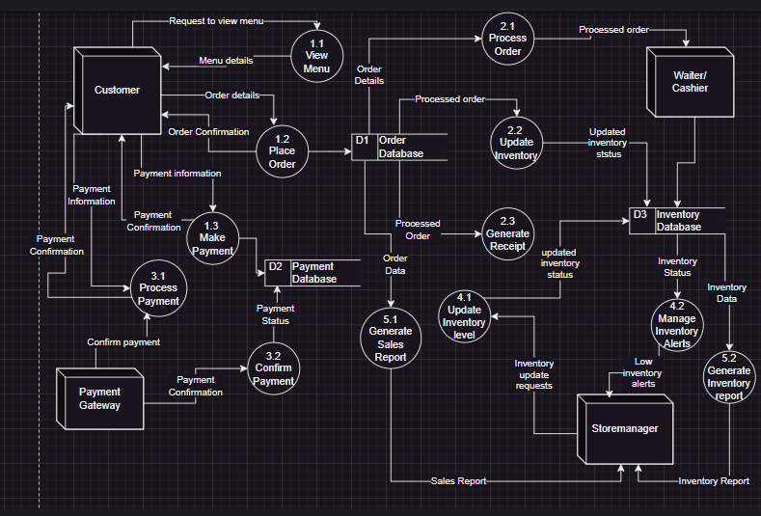

(Bograin, 2017)

Fig: Level 2 DFd Diagram of Northside Cafe Management System

# Class Diagram

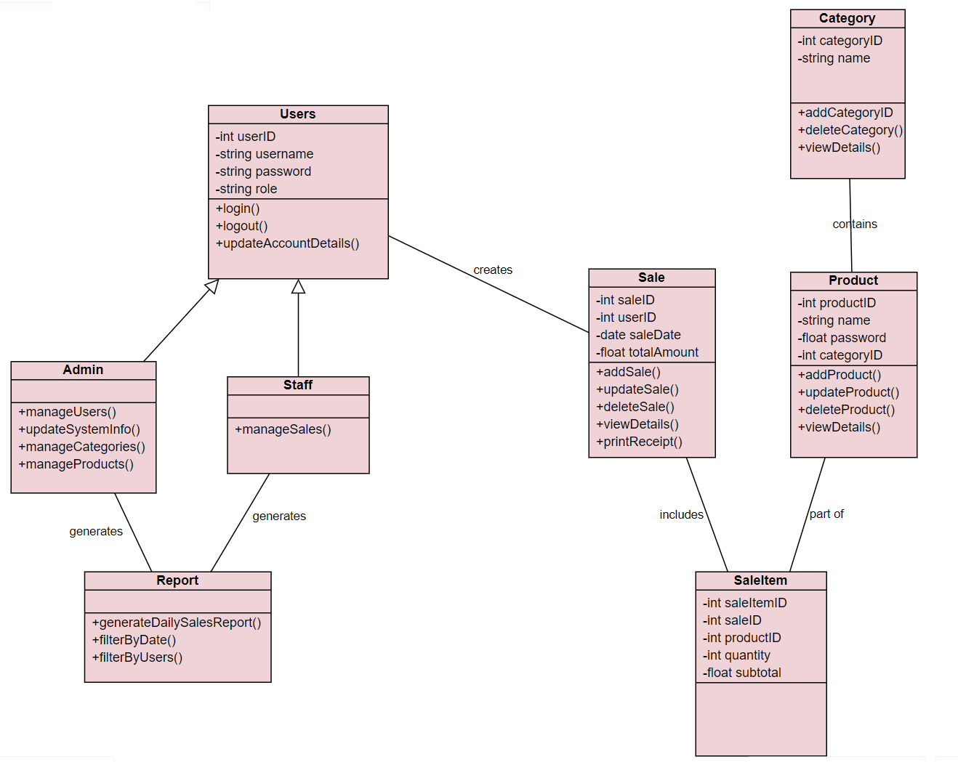

Fig: Class Diagram

# 



# UI Design & Story Boards

The following wireframes are designed considering design principles to make the user experience positive. White space, grids and intuitive buttons are emphasized to make the system as user-friendly as possible (upqode & upqode, 2022). The software used to construct the wireframes is Canva.

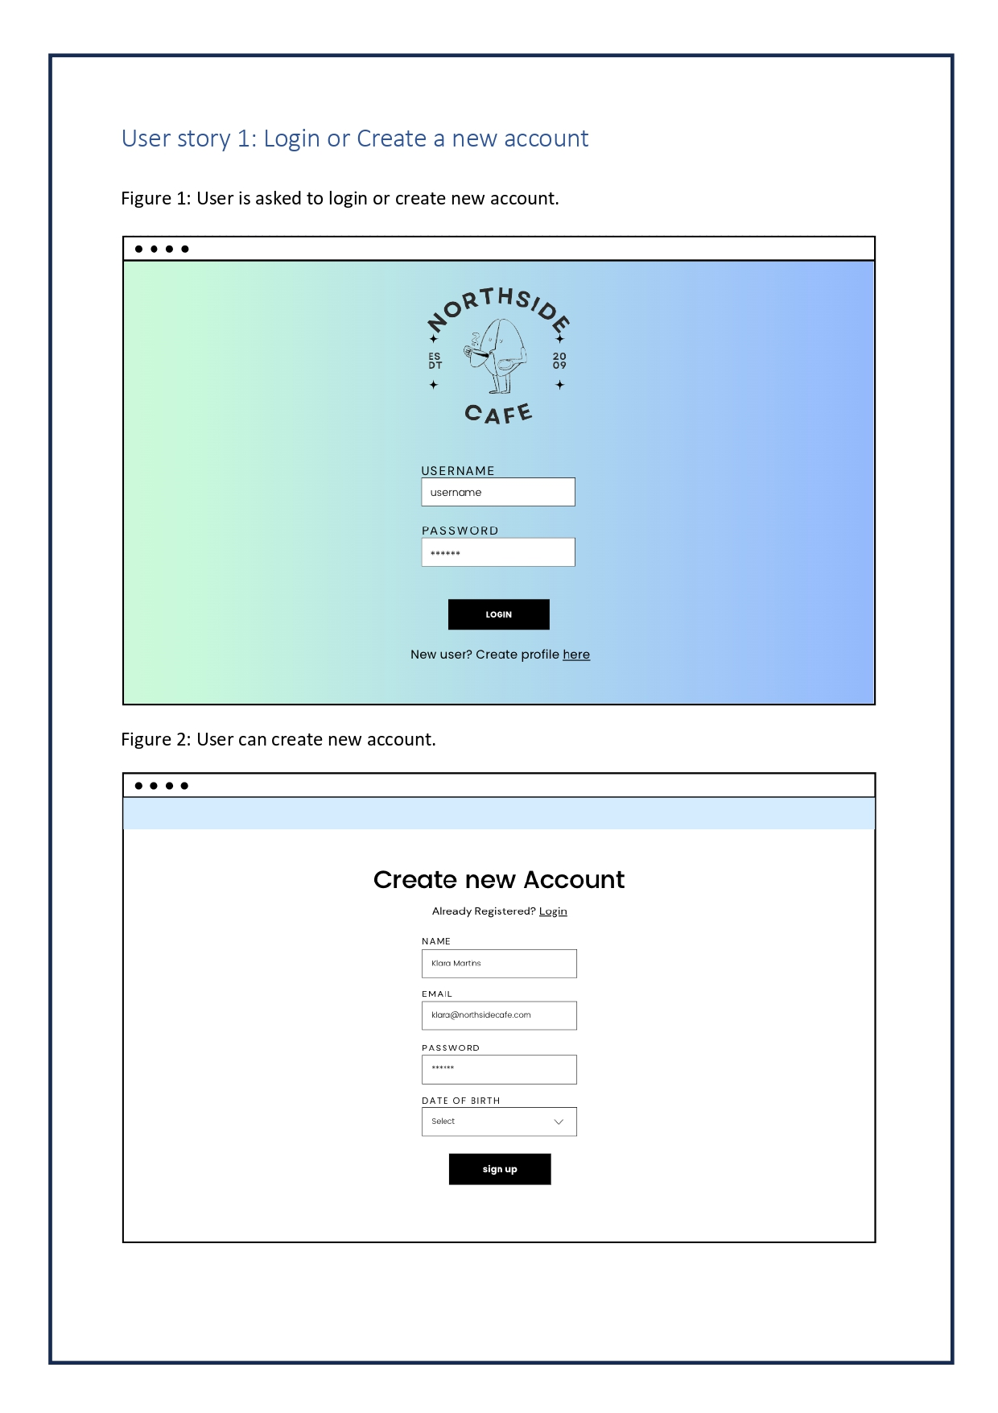

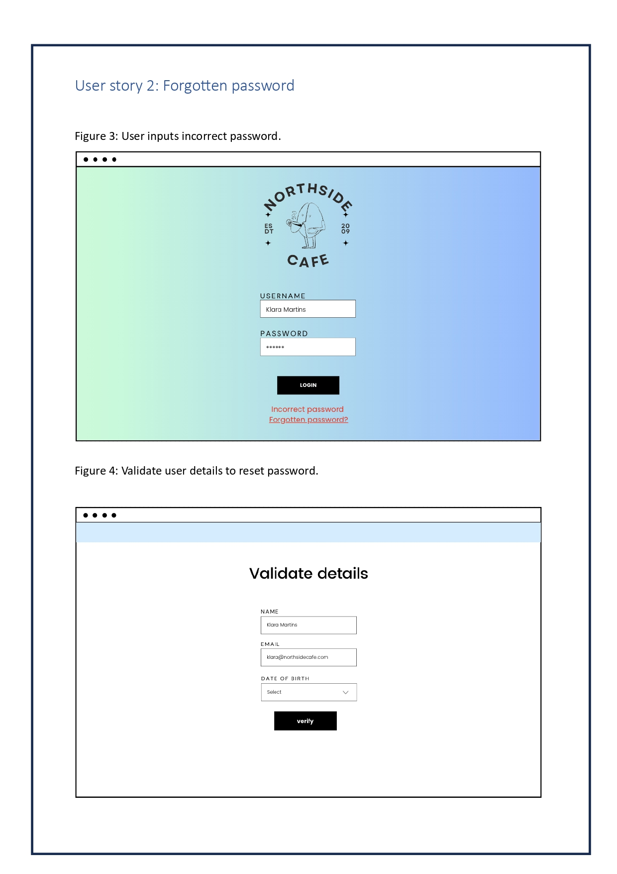

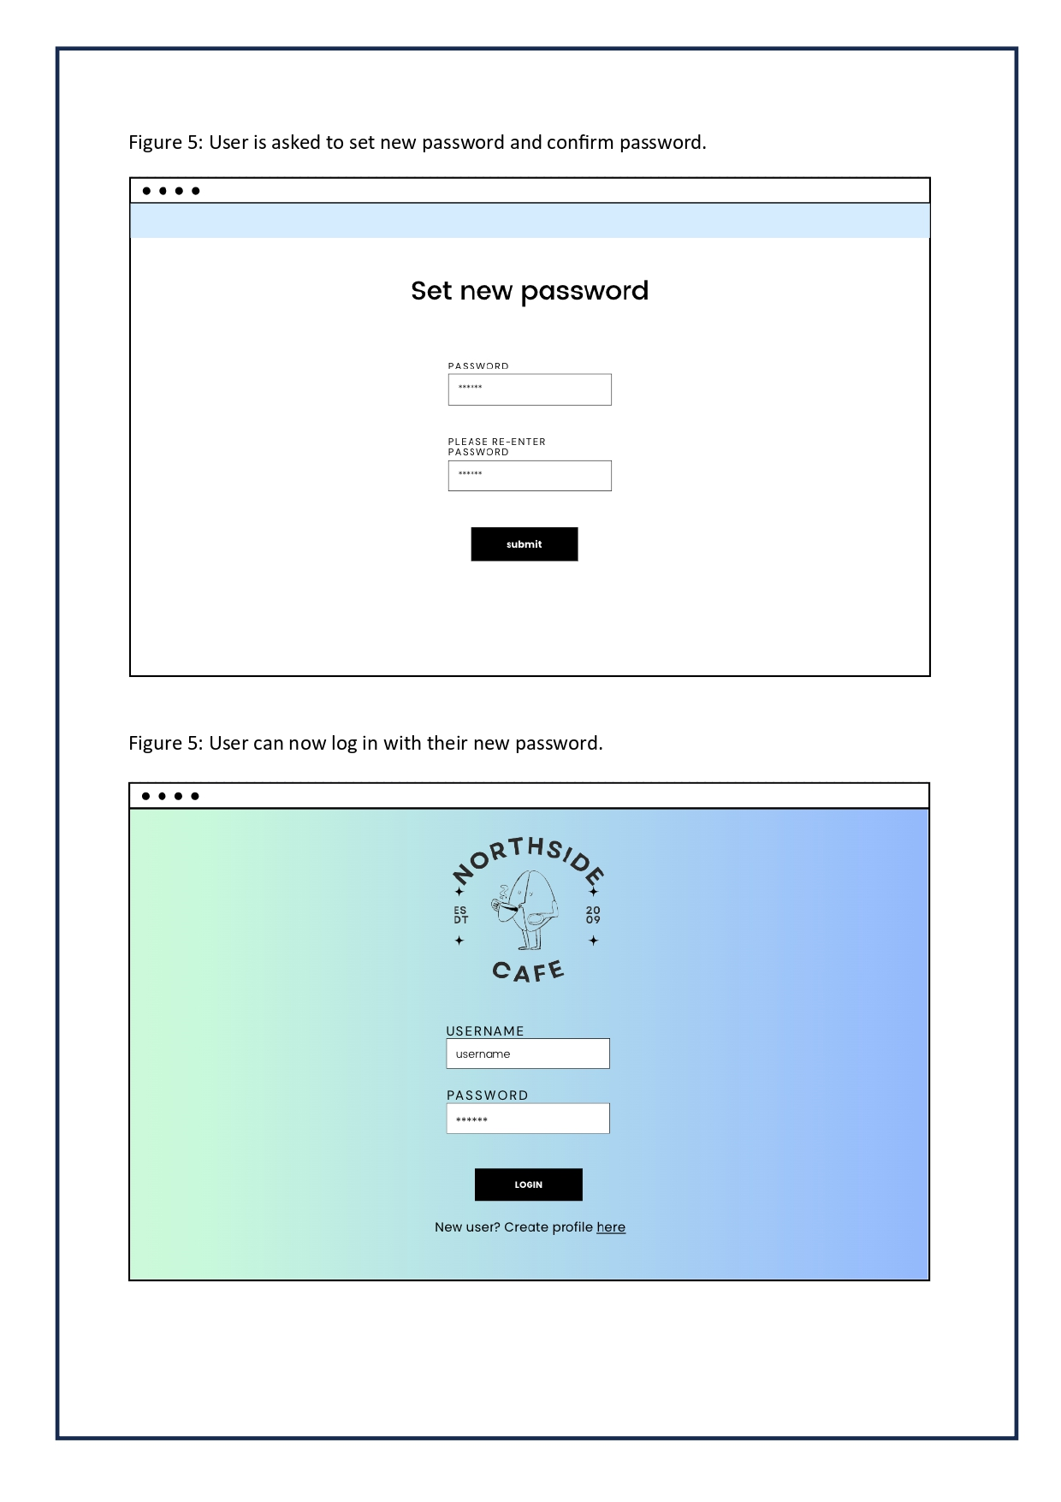

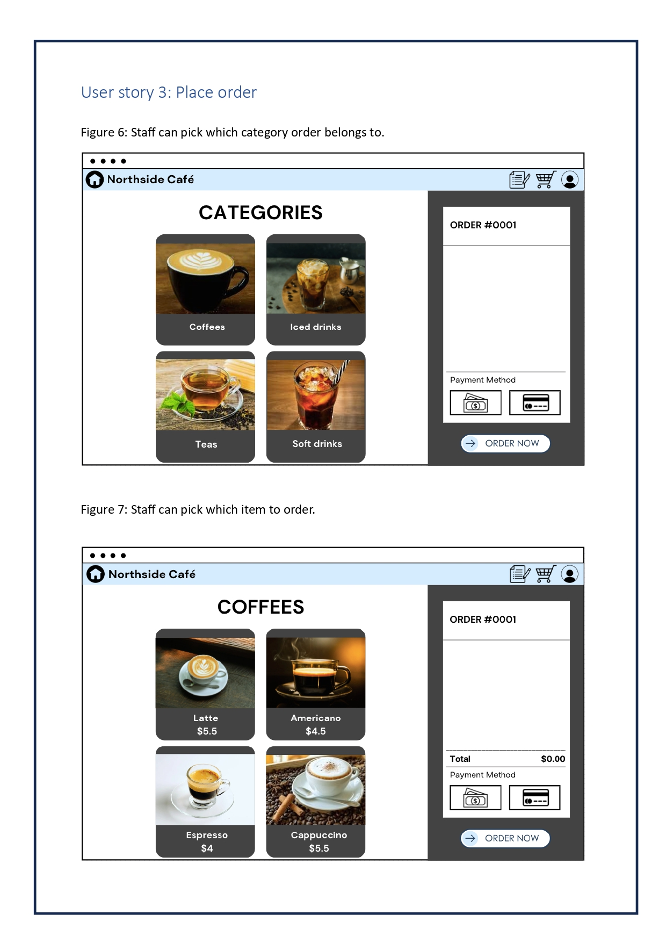

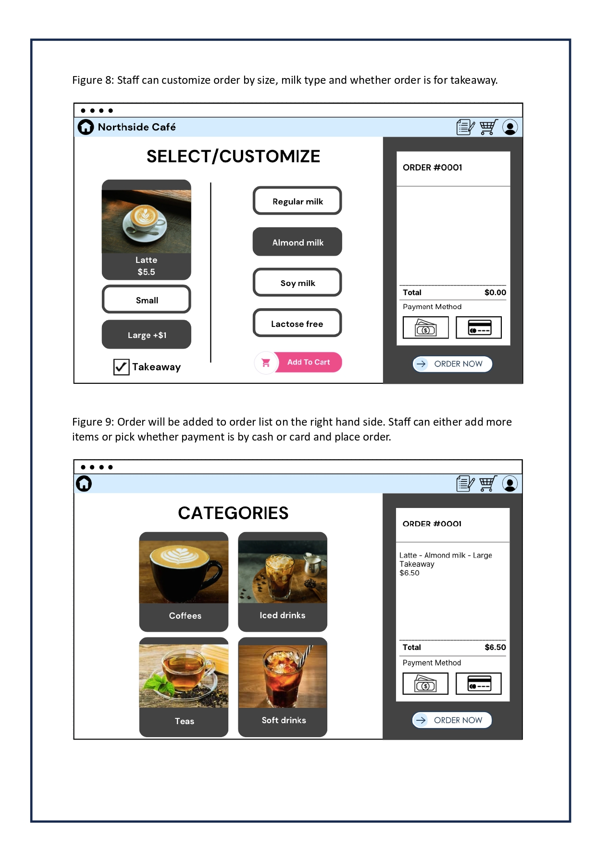

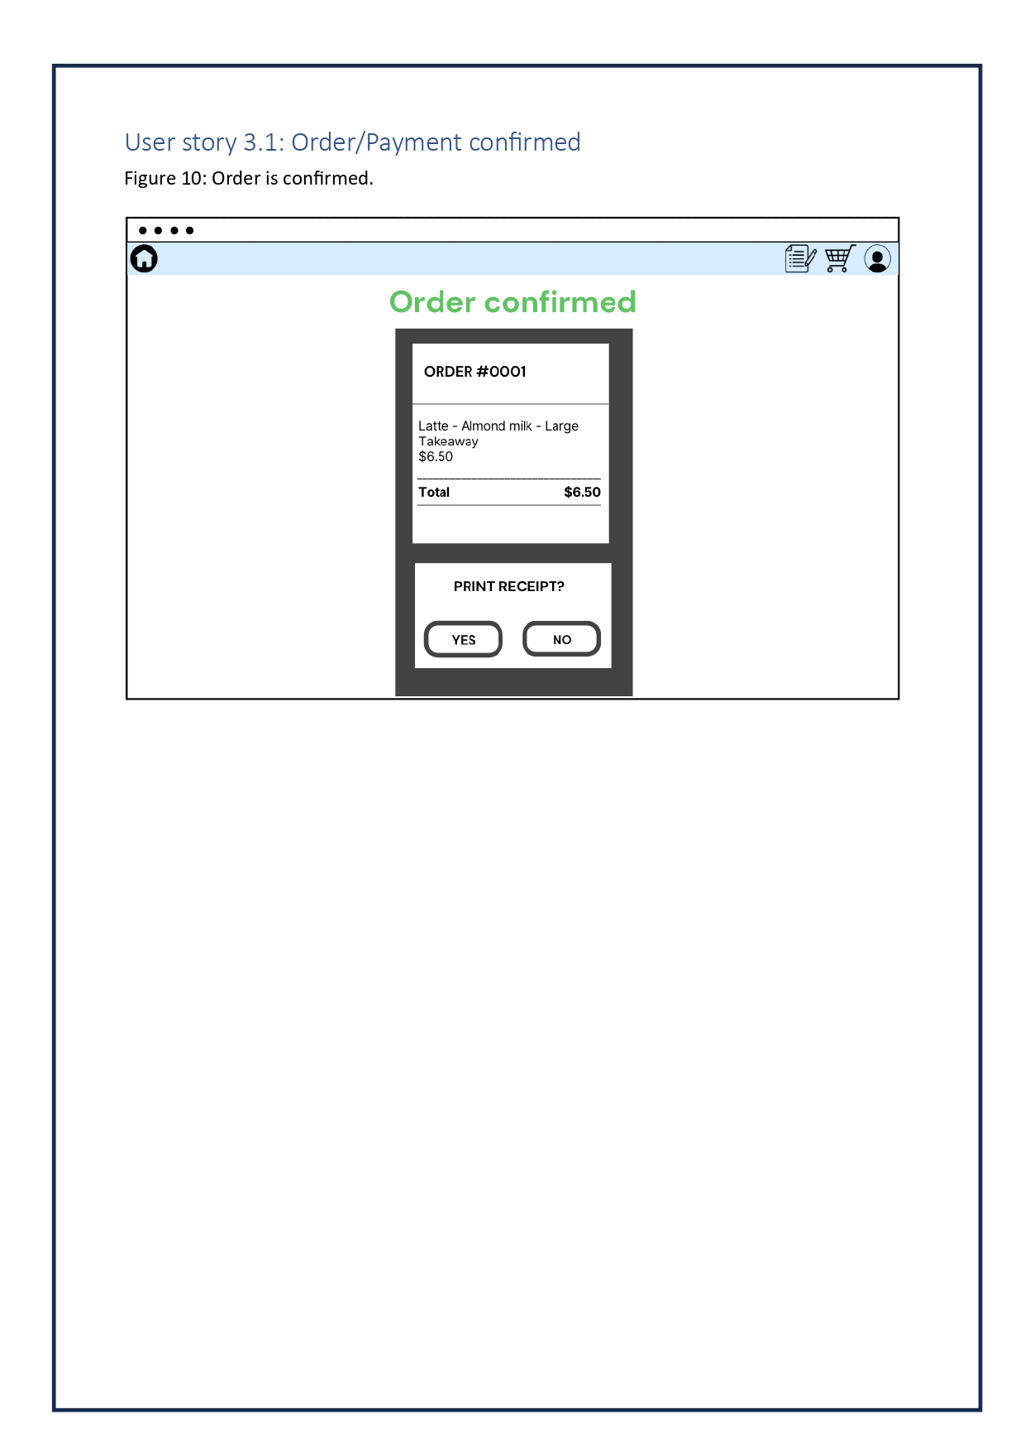

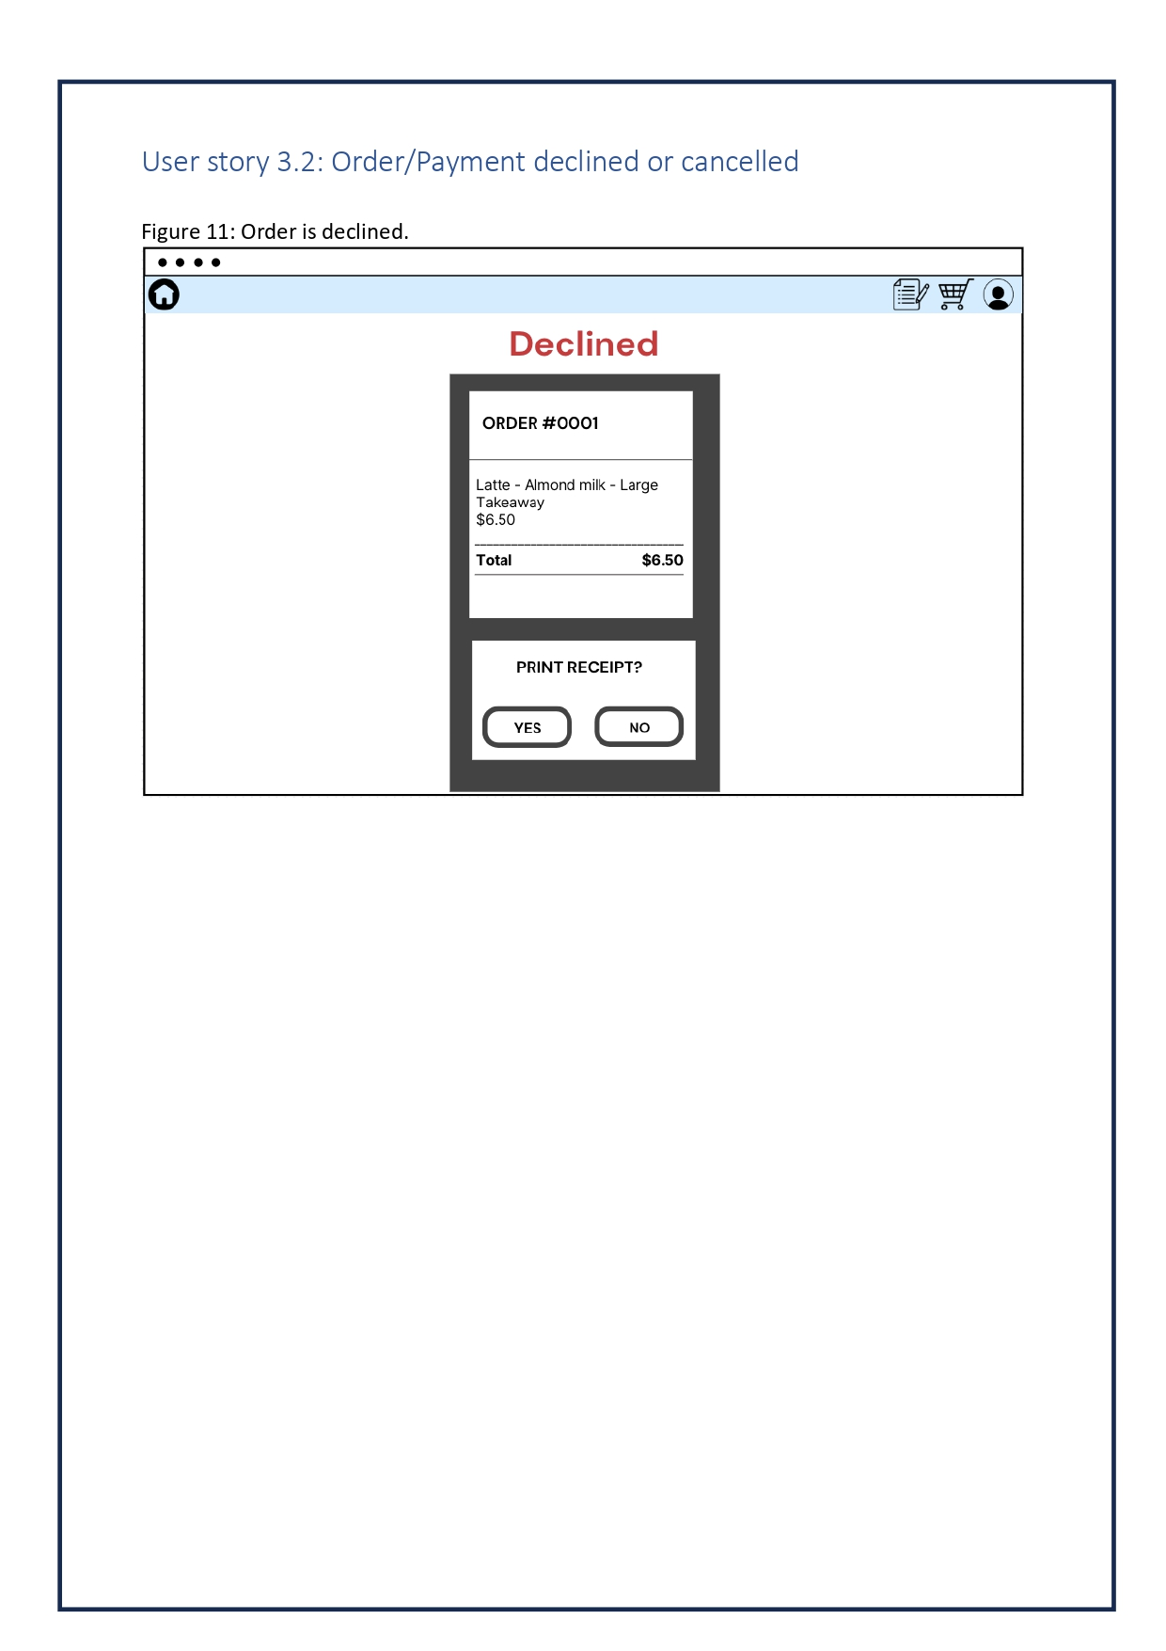

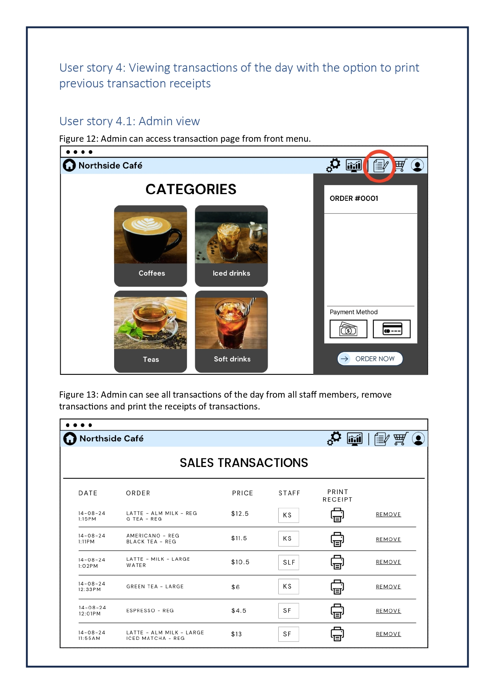

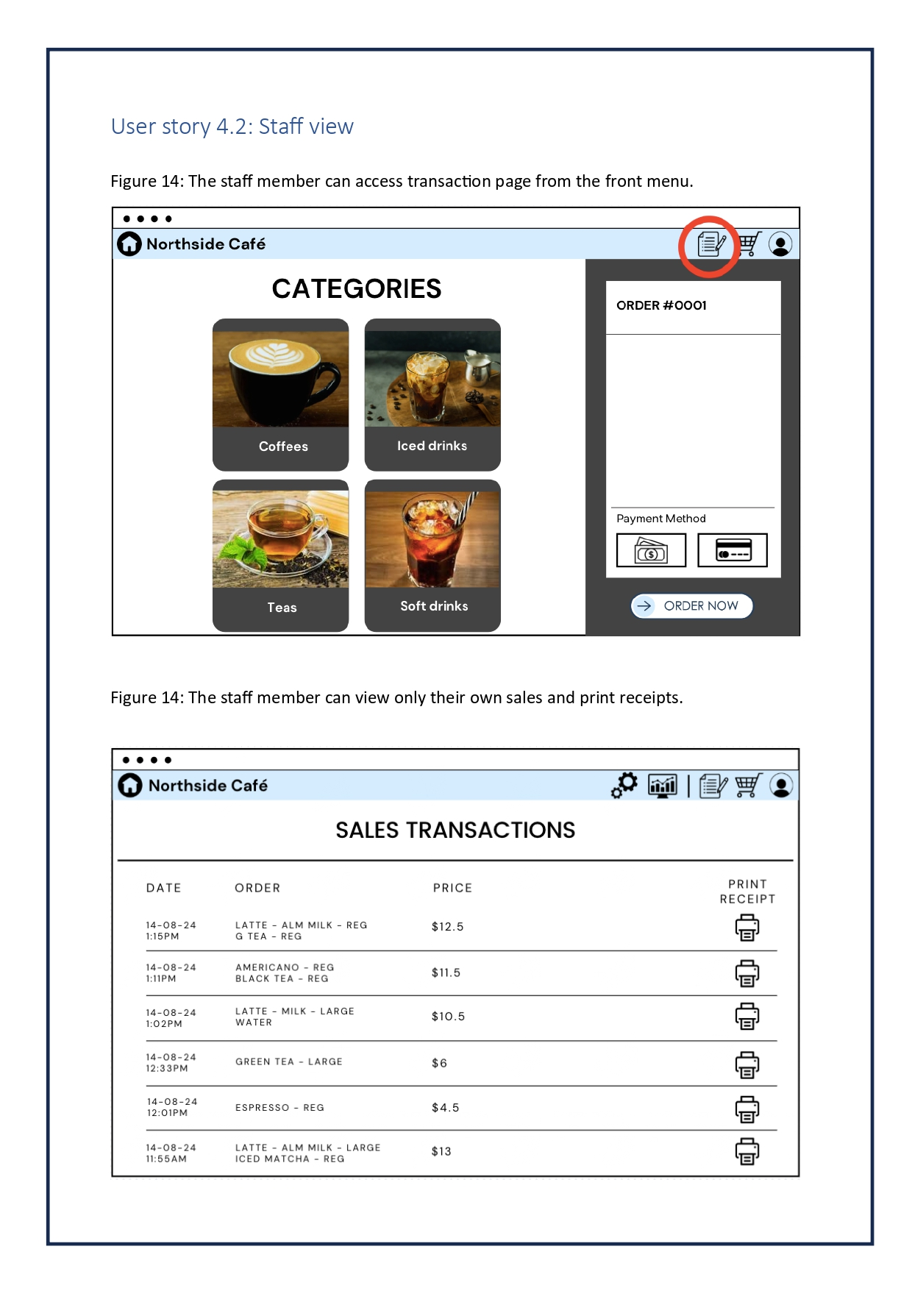

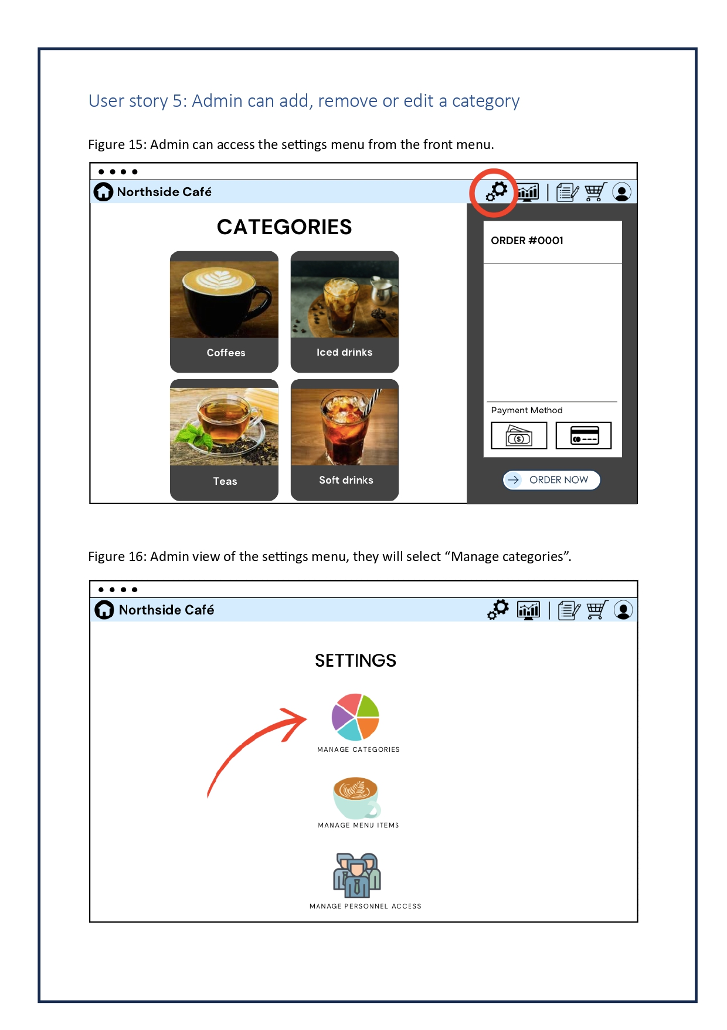

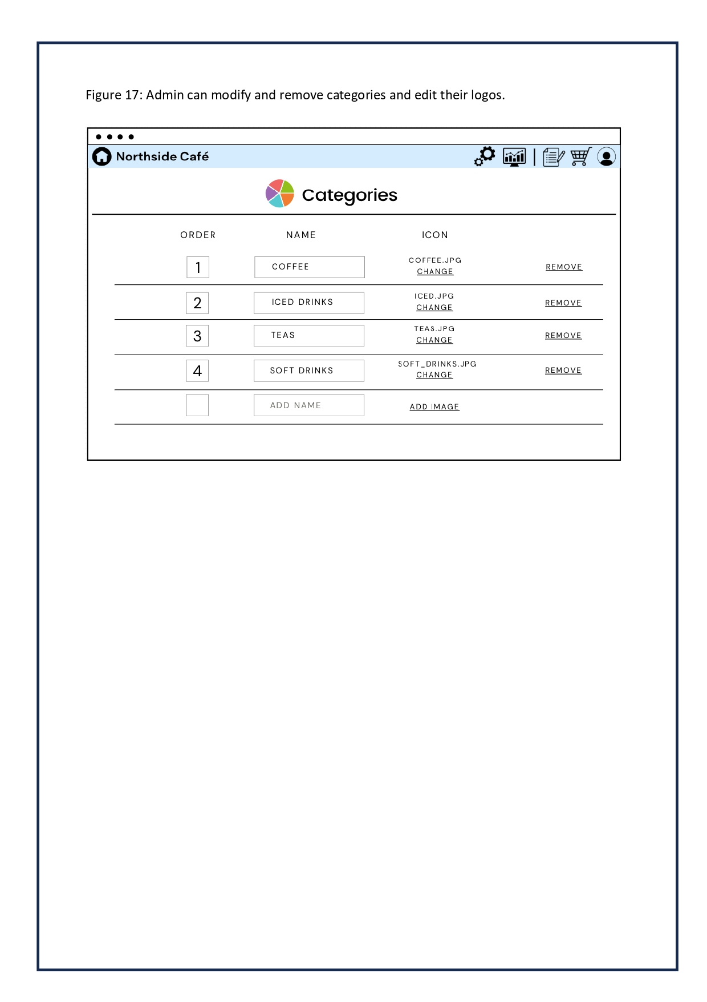

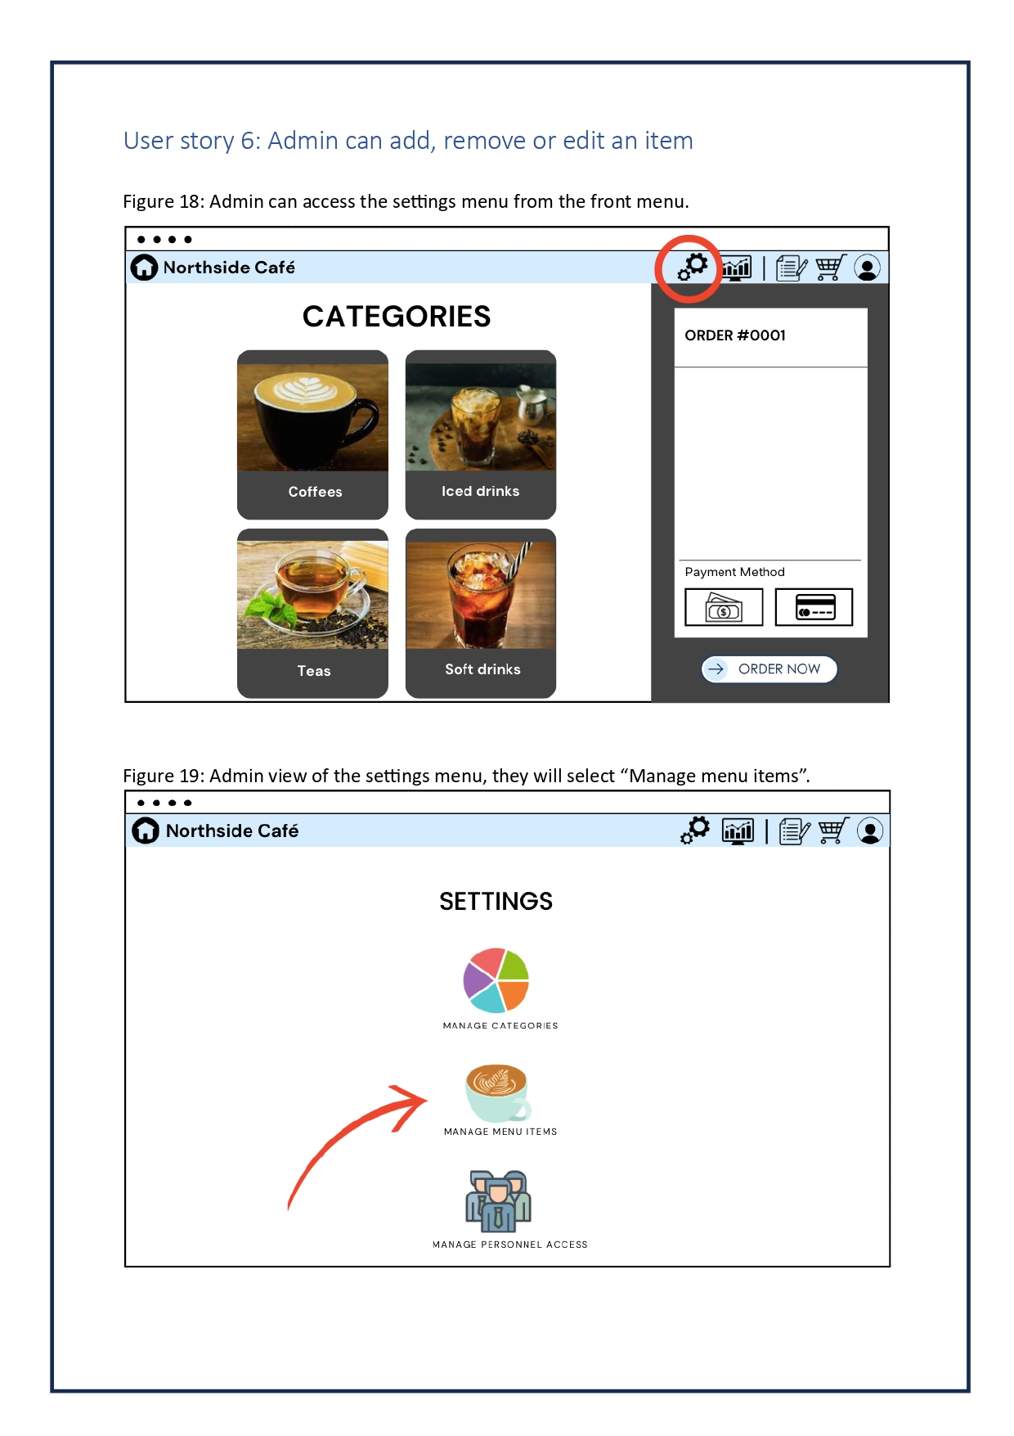

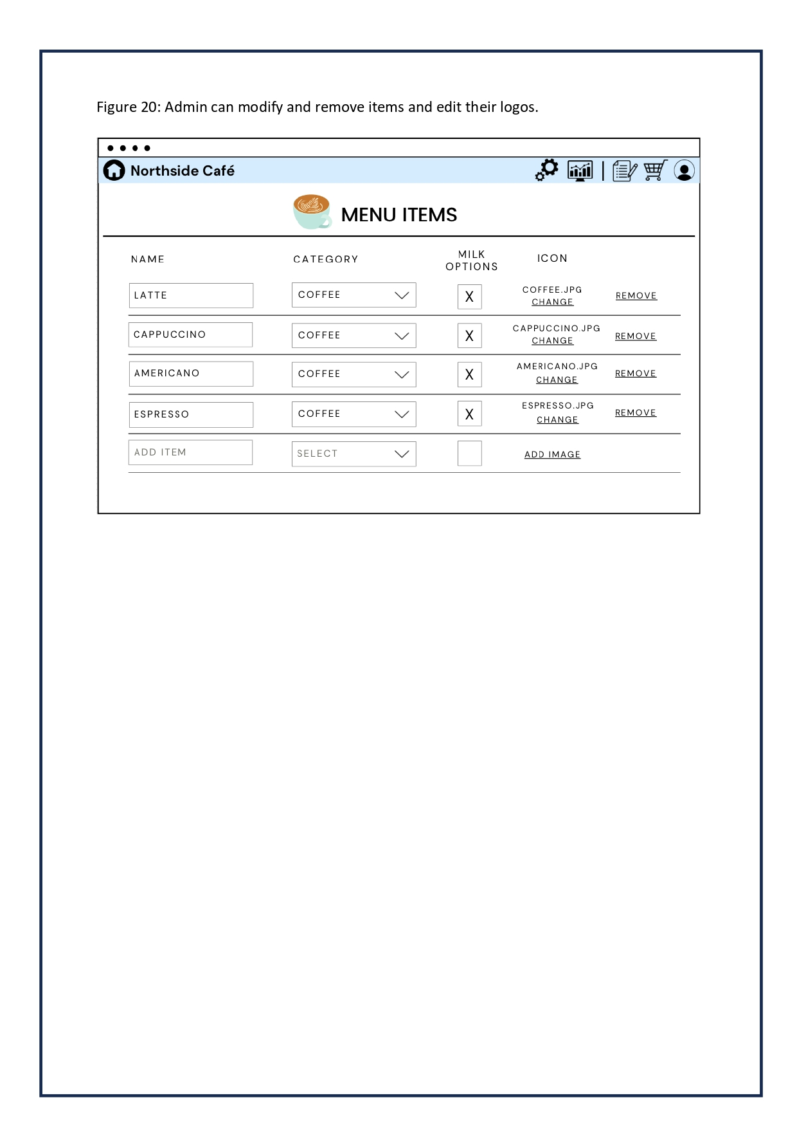

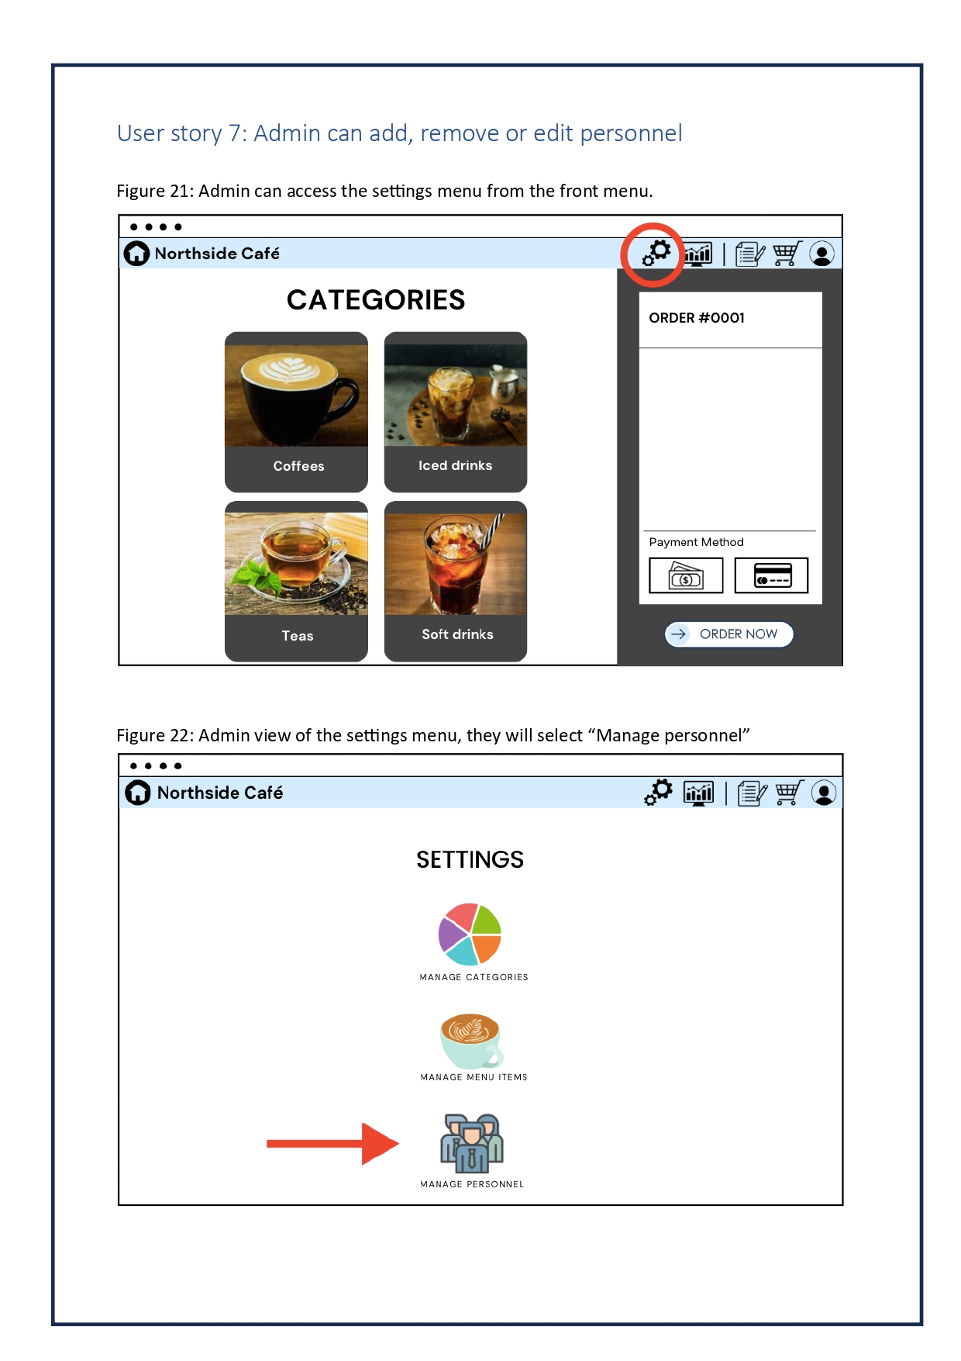

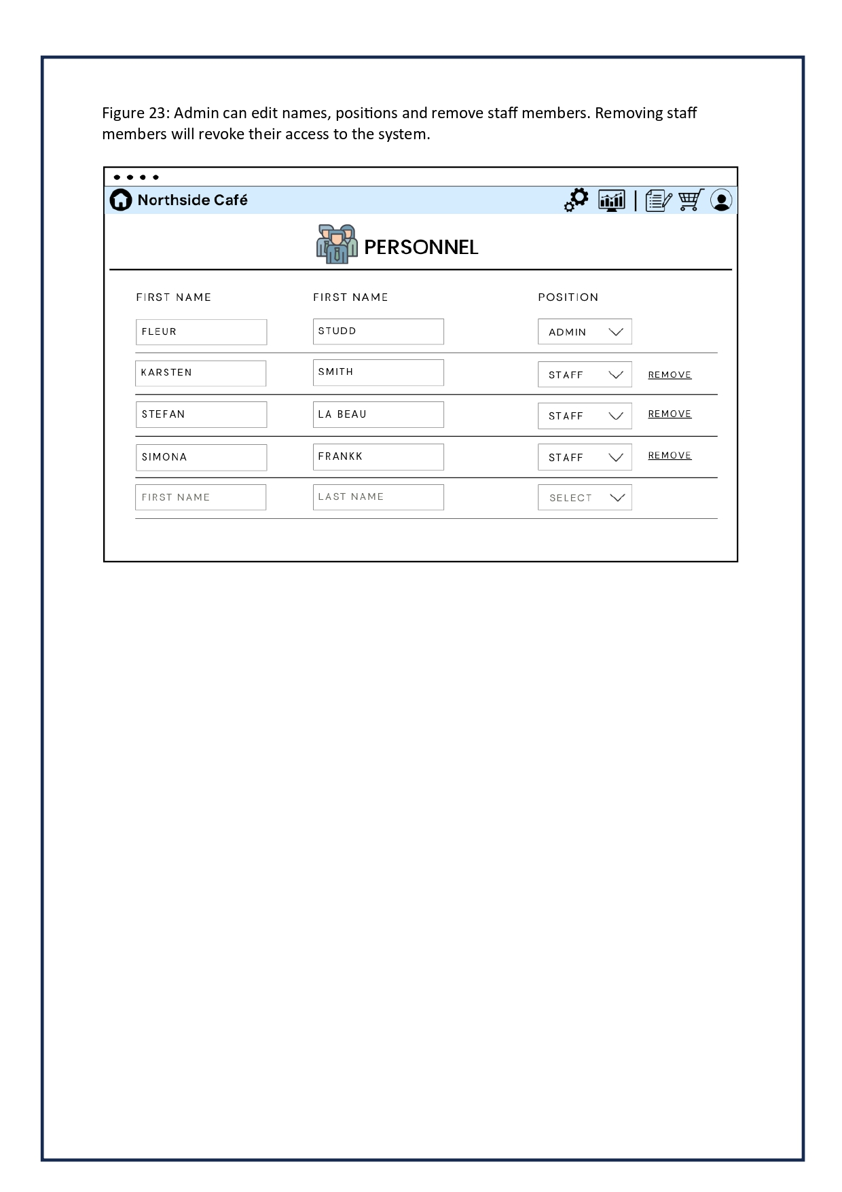

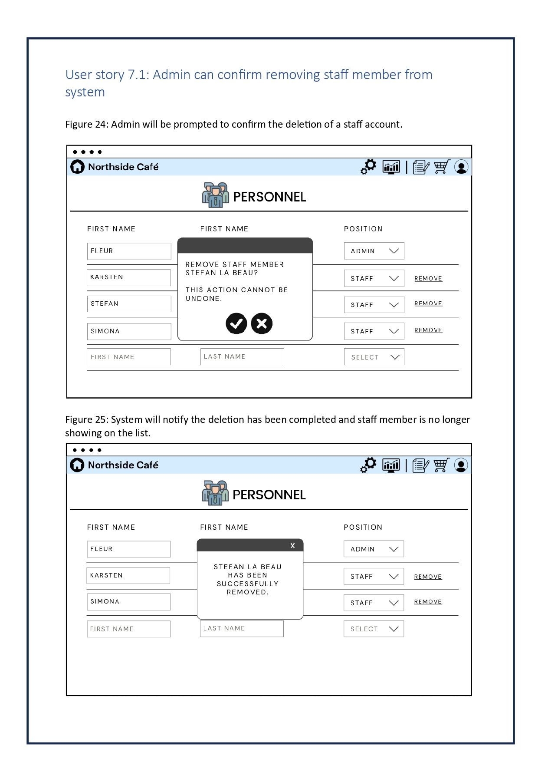

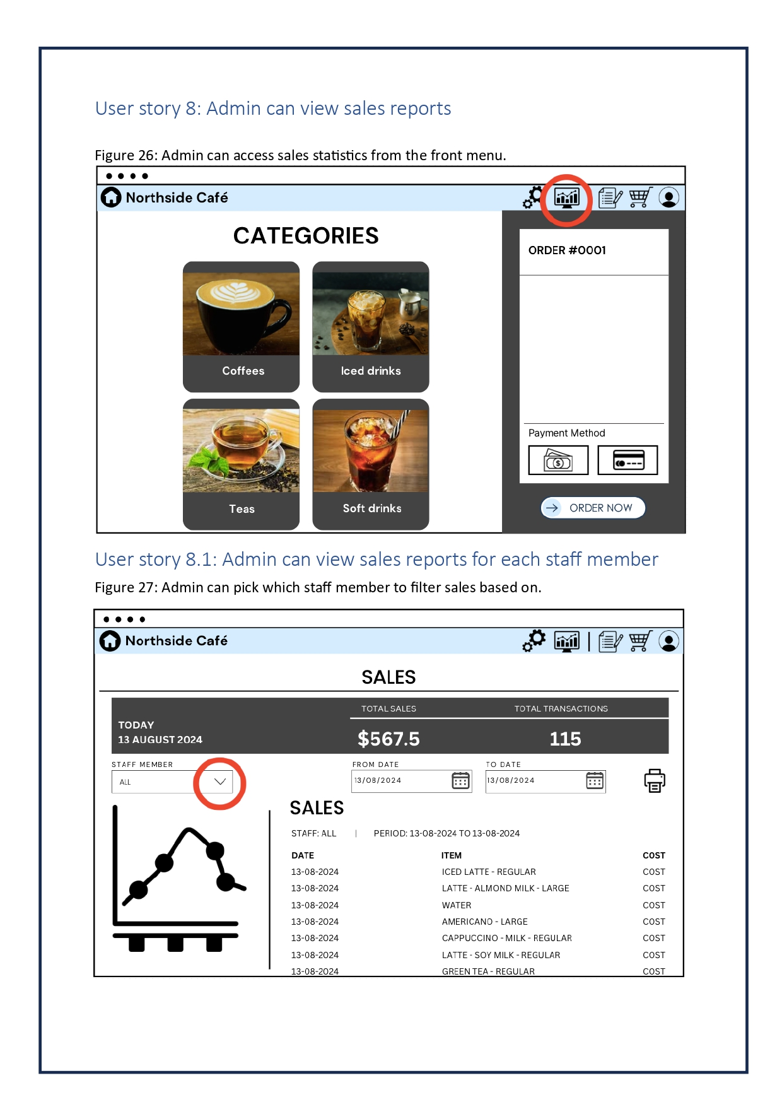

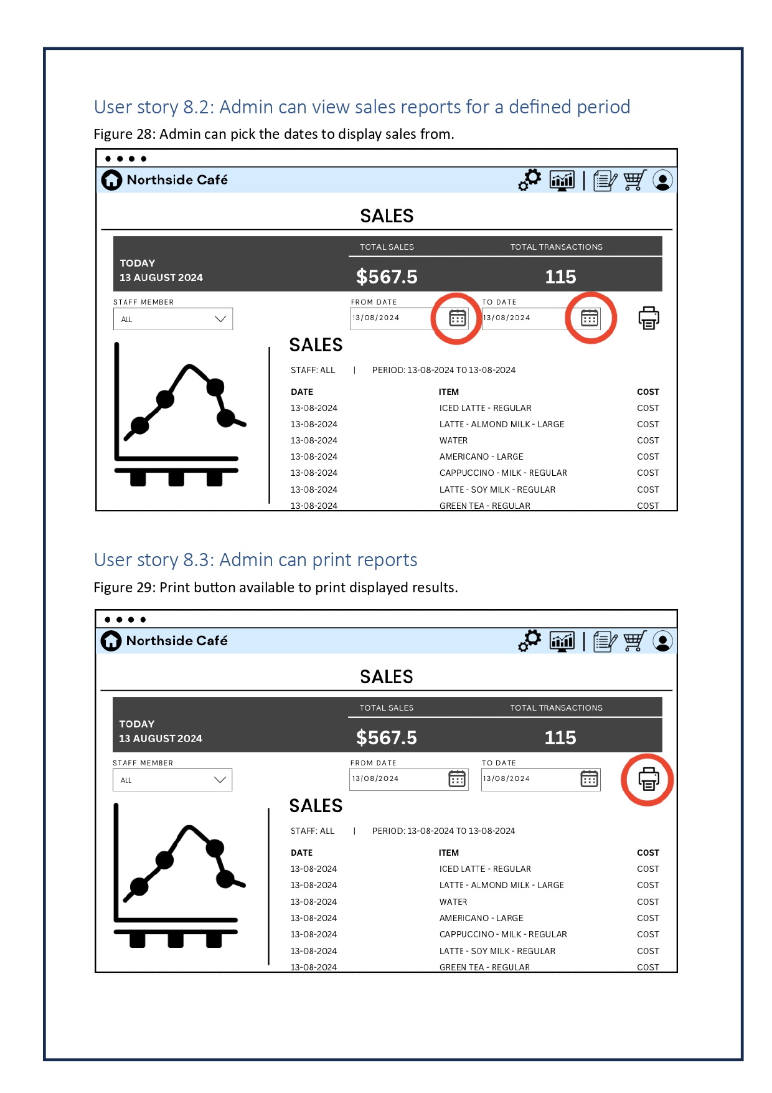

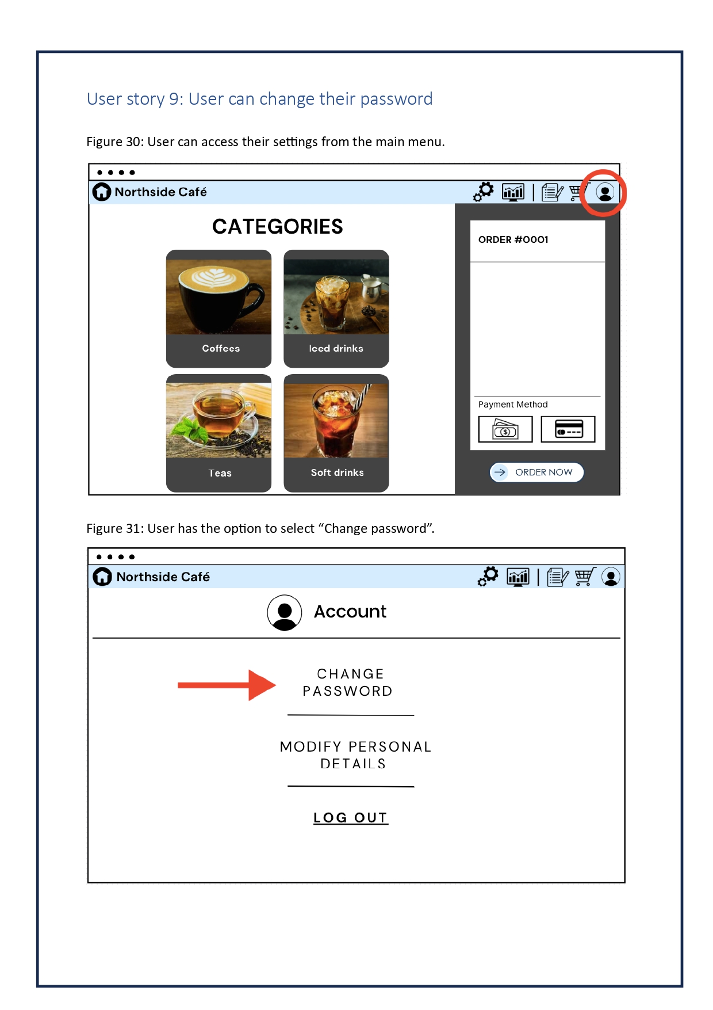

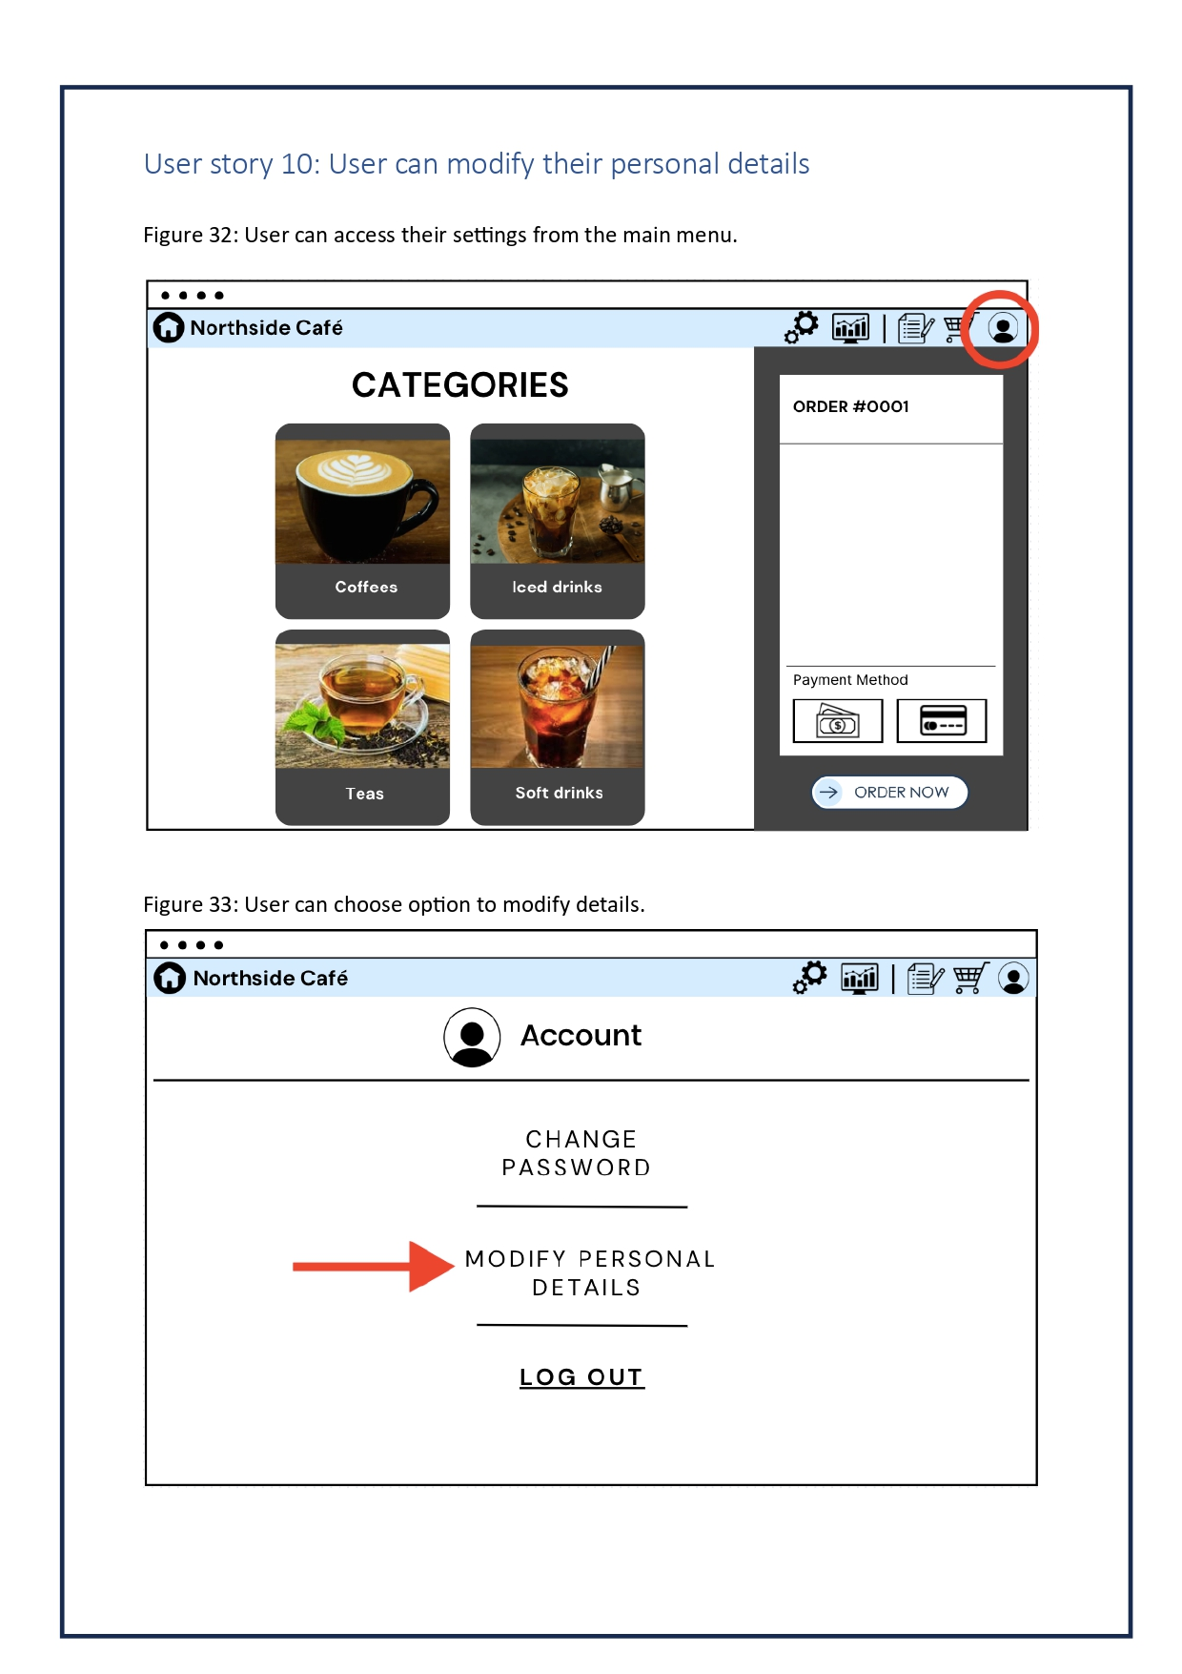

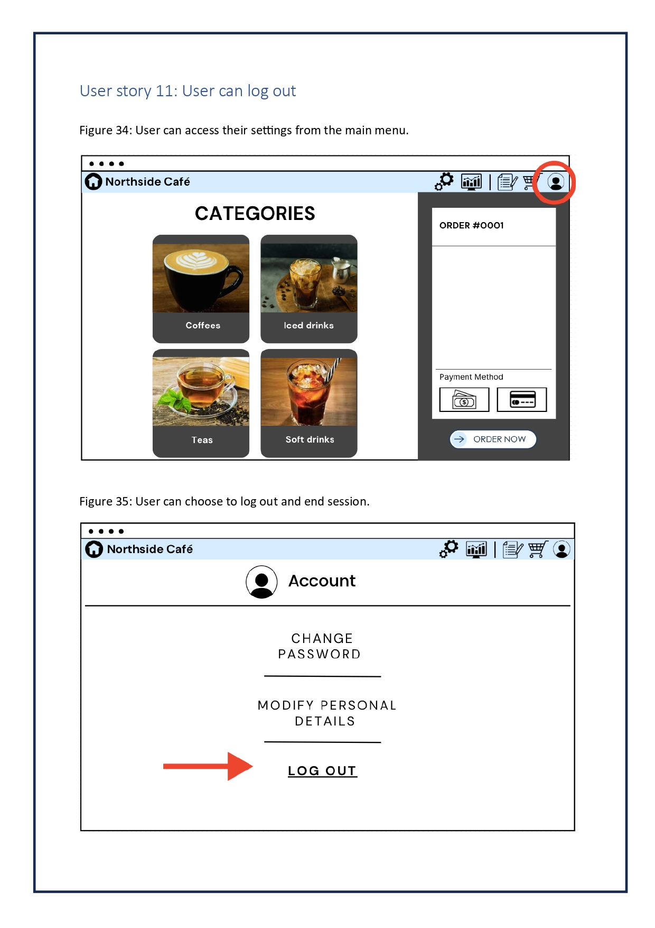



# Database Requirements:

For a database to be designed properly, it requires the identification of its entities, attributes and their relationship. The entities include the users, products, sales and orders which are responsible of the operation of the cafe and are represented by a table. Similarly, attributes are the characteristics that are used to define the entities and are represented by the column. Below is a table that shows a clear picture of the entities and its attributes.

## Database Table:

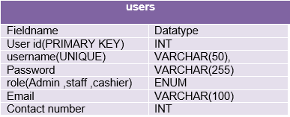

Fig: Users table

This table contains the user information such as their unique id, name, email, password, role and address.

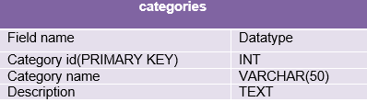

Fig: categories table

This table contains the basic information of the categories such as its unique id, name and description.

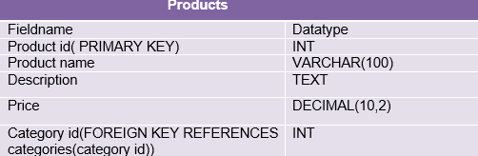

Fig: products table

This table contains the information of products such as its unique id, name, description and price.

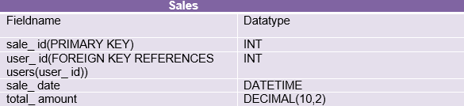

Fig: sales table

This table contains the information of sale such as its unique id, sale date and total_ amount.

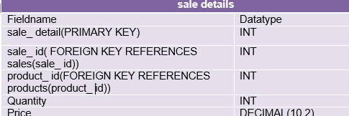

Fig: sale details

This table contains the details of sale such as price and quantity.

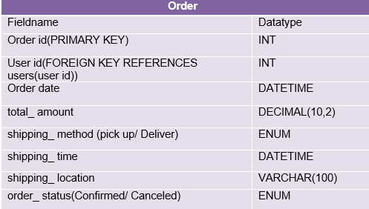

Fig: order table

This table contains the information of order such as its unique id, order date, shipping method, shipping time , location and its status.

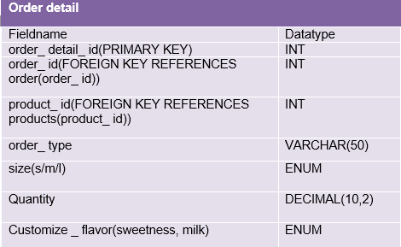

Fig: Order details table

This table contains the detail of the order such as order type , size, quantity.



## Entity Relationship Diagram:

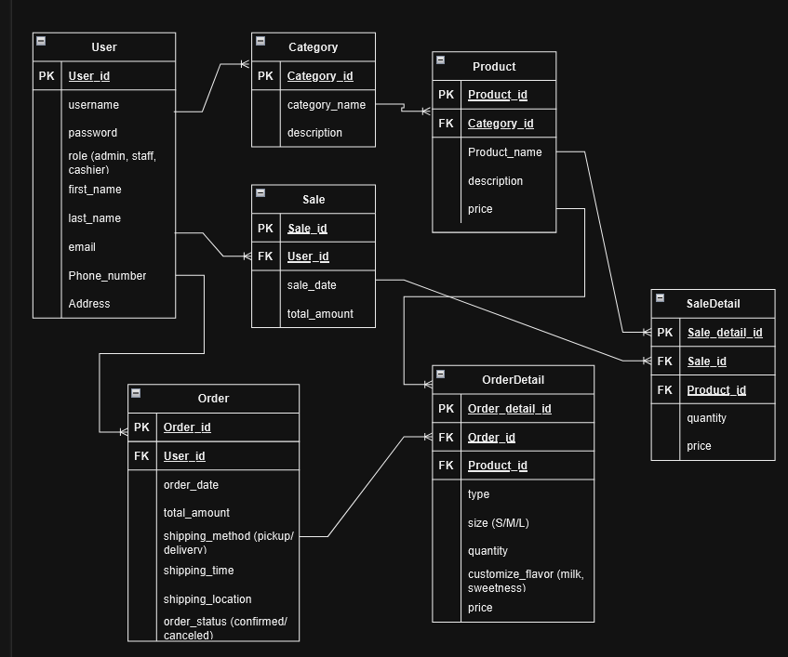

Fig: ERD diagram of Northside Cafe Management System

## Relationship Table

Z

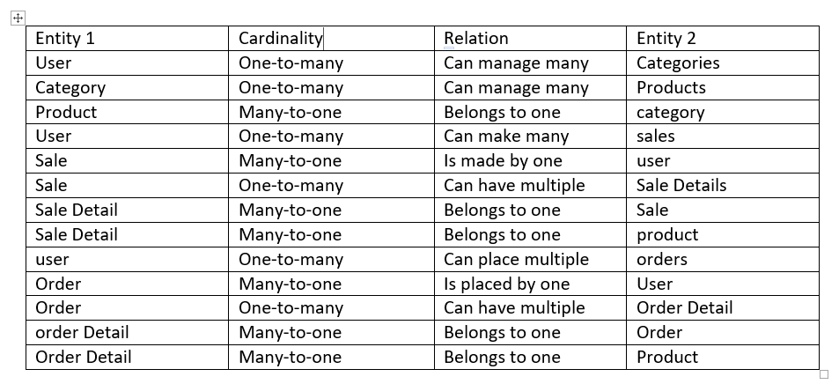

# 

# Test plan

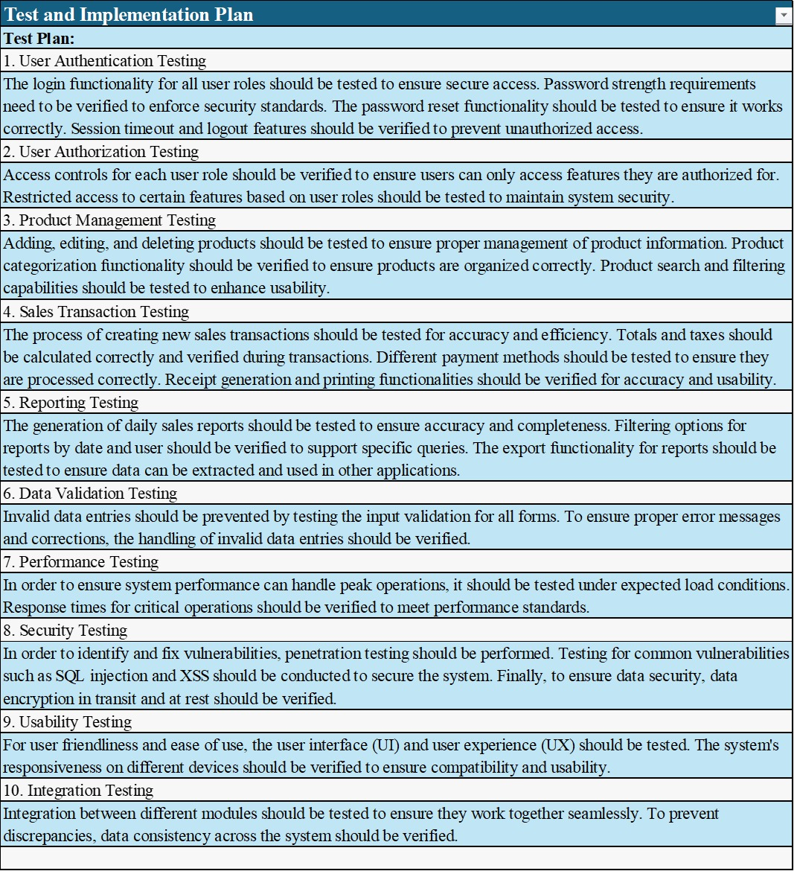

## System Implementation Plan

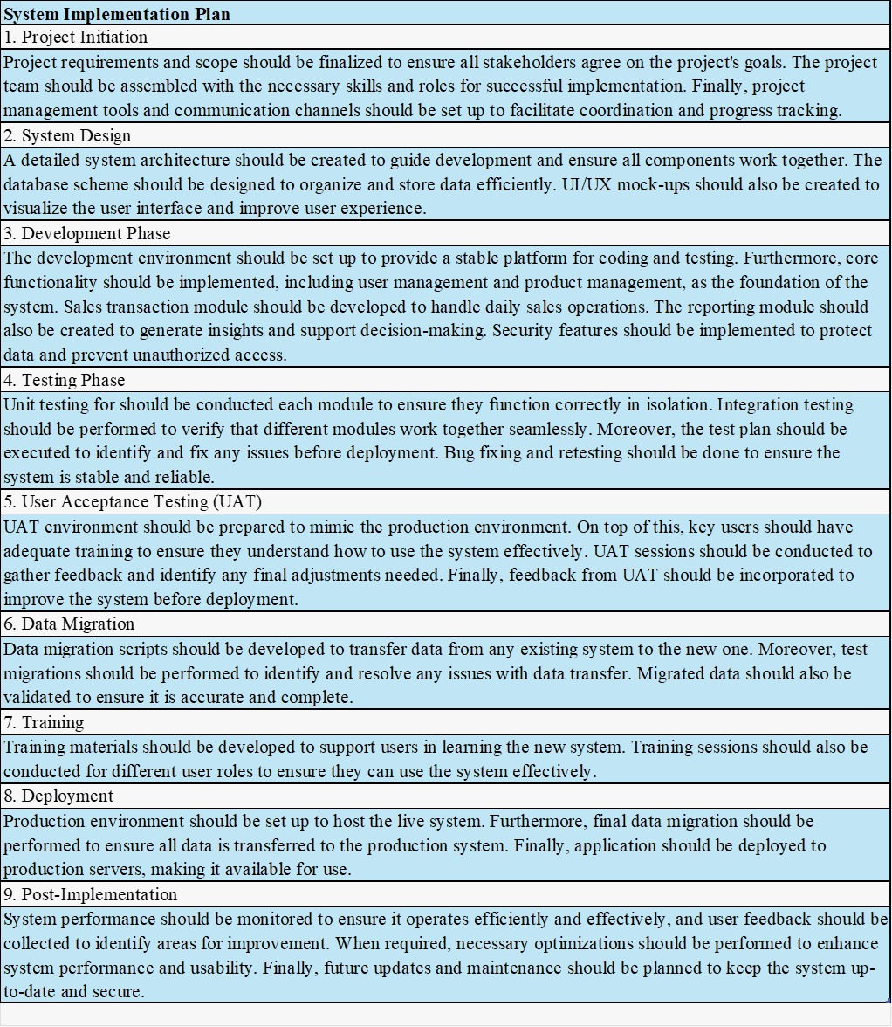

## Data Protection Impact Assessment (DPIA):

A Data Protection Impact Assessment (DPIA) outlines a procedure intended to detect and, to the greatest extent and as soon as feasible, reduce risks associated with the processing of personal data. (*Data Protection Impact Assessments | Data Protection Commission*2018)

· Identification of the processed personal data and document them.

· Identification of the possibilities of risks.

· Implementation of the Strategies to overcome the risks.

· Proving that our company complies with GDPR in order to stay out of trouble.

· Setting up methods for ongoing evaluation and revision of data security.



# Data Encryption and Anonymization:

a. Data Encryption: Data encryption is very important for the protection of data that is considered to be sensitive & is managed by the Northside Café POS system. This includes using strong encryption algorithms like AES for data both at rest and in motion. If any information is captured or viewed, then encrypted data renders that information useless. “As far as privacy and barring unlicensed entry to data are concerned, the connections between the POS system and the server should be using secure protocols like HTTPS (Teskalabs, 2024).”

b. Data Anonymization: Northside Café prioritizes safeguarding consumer information by implementing data anonymization procedures and securing the data. This involves concealing details from the data to prevent individuals or customers from being linked directly to their information. “Techniques like data masking, tokenization or generalization are utilized and implemented to maintain data usability, for analysis and reporting while ensuring privacy protection of the customers (Teskalabs, 2024).” For example, any unnecessary and personal customer data is anonymized to comply with privacy regulations & safeguard customer identities.

# Conclusion

To conclude, developing the Northside Cafe Online Management System serves not only as a modern approach but also significantly fosters the growth of the cafe with its efficient and user-friendly Point of Sale(POS) System. The implementation of key features such as role-based access control, real-time order tracking and customizable product options will contribute to the system effectively. Moreover, the ability of the system to generate detailed sales report and handle customer orders along with meeting the functional and non-functional requirements make it easier and reliable. This project will serve as an ultimate solution to help Northside Cafe achieve their goals and set a strong impression in a competitive market.



# Reference list

* *6 Necessary Point of Sale Hardware Components* 2021, Alice POS.
* *6 Things You Need to Setup Your POS* 2019, Erply.
* BCS Consultants. 2024. How to choose the best door access control system for your business. [online] Available at: https://www.bcsconsultants.com/blog/how-to-choose-the-best-door-access-control-system-for-your-business/#:~:text=Cloud%2DBased%20Access%20Control%20Systems,in%20their%20access%20control%20solutions  [Accessed 11 August 2024].
* Bograin, E., 2017. Analysis of Human Resource Management System Using Data Flow Diagram. *Libyan Journal for Engineering Research*, *1*(1).
* *Data Protection Impact Assessments | Data Protection Commission* 2018, Data Protection Impact Assessments | Data Protection Commission, viewed 17 August 2024, <https://dataprotection.ie/en/organisations/know-your-obligations/data-protection-impact-assessments#what-steps-are-involved-in-carrying-out-a-dpia>.
* Elmasri, R & Navathe, S 2016, *Fundamentals of database systems*, 7th edn, Pearson.
* Harrington, J.L., 2016. *Relational database design and implementation*. Morgan Kaufmann.Vancouver
* Laumal, FE, Wabang, JA, Suharto, RSB, Plaimo, PE & Ndoloe, LA 2019, ‘Development of Web-based Coffee Management Information System to support the Management of Regional Superior Products’, *Journal of Physics: Conference Series*, vol. 1424, no. 1, p. 012008.
* Maranatha Christian University. (2024). Title of the Article. International Conference on Entrepreneurship (ICE), Volume 1(Issue 1), pp. 1-10. Available at: https://journal.maranatha.edu/index.php/ice/article/download/3321/1780 [Accessed 11 August 2024].
* Nindel-Edwards, J & Steinke, G 2015, ‘The Development of a Thorough Test Plan in the Analysis Phase Leading to more Successful Software Development Projects’, *Communications of the IIMA*, vol. 5, no. 1.
* Palmer, J, Aupperle, H, Bredemeier, J & Duso, C 2017, *Software Test Plan Version 1.0 WibTeX Reference Management System Software Test Plan WibTeX*, viewed 17 August 2024, <https://www.ceias.nau.edu/capstone/projects/CS/2017/WibTex/Documents/test_plan_cs486c_aupperle_bredemeier_duso.pdf>.
* Schader, M & Axel Korthaus 2012, *The Unified Modeling Language*, Springer Science & Business Media.
* Schwalbe, K 2014, *Information Technology Project Management*, 8th edn, Cengage Learning.
* Solutions, R 2023, *POS System Features and Requirements Checklist*, Medium.
* Teskalabs. 2024. Data privacy: pseudonymization, anonymization, encryption. [online] Available at: https://teskalabs.com/blog/data-privacy-pseudonymization-anonymization-encryption [Accessed 11 August 2024].
* Tris C. 2024. Best firewalls for small businesses 2024. [online] Available at: https://www.goallsecure.com/blog/best-firewalls-for-small-businesses-2024/ [Accessed 11 August 2024].
* upqode & upqode 2022, *Design Concepts for Building a Website: Main Points to Consider*, Web Design Agency - Upqode, viewed 17 August 2024, <https://upqode.com/design-concepts-for-building-a-website/>.
* n.d., Canva, viewed 17 August 2024, <https://canva.com>.